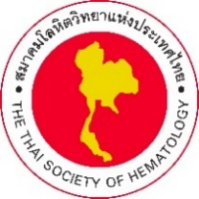

19th TSH Webinar
Philadelphia chromosome-positive leukemia
Friday, December 10, 2021 at 13.30-15.30 Hrs.

PROGRAM

13.30-14.30 Ph+ acute lymphoblastic leukemia
Moderator: Lalita Norasetthada, MD (Maharaj Nakorn Chiang Mai Hospital)

- How to induce remission in Ph+ALL: High or low intensity therapy
Wasithep Limworapitak, MD.
(Thammasat University Hospital)
- How to maintain the long-term response: TKIs or allogeneic stem cell transplant or CAR-T cell therapy
Chantiya Chanswangphuwana, MD.
(King Chulalongkorn Memorial Hospital)

14.30-15.30 Corporate Symposium by Thai Otsuka
Moderator: Adisak Tantiworawit, MD (Maharaj Nakorn Chiang Mai Hospital)

- When is Ponatinib an appropriate treatment option for CML patients?
Prof. Gianatonio Rosti
(University of Bologna, Italy)

